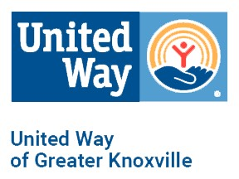

KNOX COUNTY COVID -19 RESPONSE FUND MINI GRANT APPLICATION
Funding Available for Phase 1: $50,000
Please email applications to Leslie Dancu at DancuL@unitedwayknox.org

Phase 1
Application Submission: March 24-March 29, 2020
UWGK Committee Review Period: March 31-April 5, 2020
Award Notification and Funding Released: April 7-9, 2020

Date:
Agency:
EIN:
Program:
CEO/Executive Director:
Email Address:
Phone Number:

Mini Grant Request Amount:

Please briefly describe the program and how the program addresses the needs of those who are impacted by COVID-19 (include the target population and the expected measurable impact):

Please describe how a mini grant will allow you to expand services or address unmet needs:

Please describe specifically how the funds will be used:

