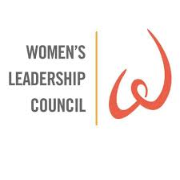United Way of Greater Knoxville’s Women United

Now with over 250 members this group of leadership donors is strong and passionate about the unending change
United Way of Greater Knoxville and its 56 partner agencies can have on the 106,500 people it serves annually.
With the goal of building an inclusive female philanthropic community and joining women around the world they are
willing to fight for the health, education and financial stability of every person in our community.

If you would like to learn more about this group, please contact:
Marie Alcorn | (865) 521-5565 | AlcornM@unitedwayknox.org

